**Project 1 -** Visualizations

**Guide:** Prof.Satwik Kamarthi

**Team 8:** Swapna Vippaturi, Aditya Mogadpally

—----------------------------------------------------------------------------------------------------------------------------

# Chart - 1

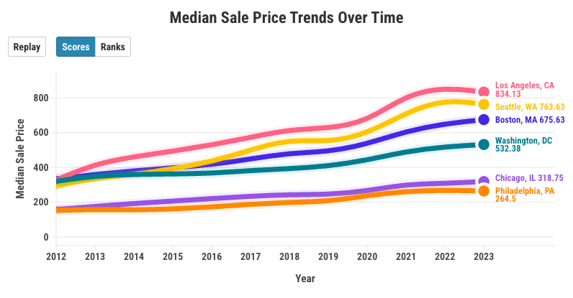

[Median Sale Price Trends Over Time | Flourish](https://public.flourish.studio/visualisation/15384846/)

**Visualization Purpose:**

This plot refers to the median sale price of all the regions over the year from 2012 to 2023. This chart helps to visualize the trend followed by the median sale price of the houses in these 6 regions providing important information regarding the rise and fall of the sale price.

**Data Analysis:**

Sale Price is the most important factor to define the real estate market value of any region. Studying this characteristic of this market is very crucial and will provide great insights and knowledge towards the opportunities of investment.

# Chart - 2

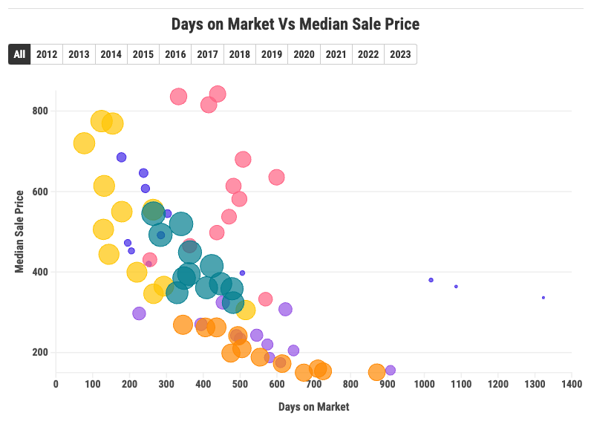

[Days on Market Vs Median Sale Price | Flourish](https://public.flourish.studio/visualisation/15450938/)

**Median Sale Price vs. Days on Market**

**Visualization's Purpose:**

This visualization is a crucial component of our investigation into the real estate market, specifically how the median sale price correlates with the number of days properties remain on the market. By plotting these variables for six different cities, we aim to gain insights into market dynamics, price trends, and property turnover rates.

**Data Analysis:**

We selected the Median Sale Price and Days on Market as variables for this visualization after conducting initial data analysis. We discovered that the length of time a property stays on the market can be a significant indicator of market health and demand. Longer days on market may suggest a lower rates of properties, while shorter durations could indicate a seller's market. Combining this with median sale price allows us to identify trends and potential opportunities or challenges in each city's real estate market.

# Chart - 3

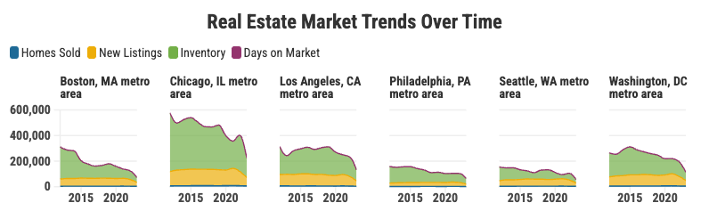

[Homes Sold Vs New Listings Vs Inventory Vs Median Sale Price | Flourish](https://public.flourish.studio/visualisation/15445661/)

**Real Estate Market Trends Over Time**

**Visualization Purpose:**

This visualization plays an important role in understanding the trends of the real estate market in the 6 cities. It helps in understanding the important characteristics of the real estate market and how they trend in correlation with each other.

**Data Analysis:**

These variables play a major role in defining the real estate market at any place in a specified time period. Analyzing these variables and characteristics of the market can help gain crucial, helpful and meaningful insights on the market and help provide potential opportunities in the future.

# Chart - 4

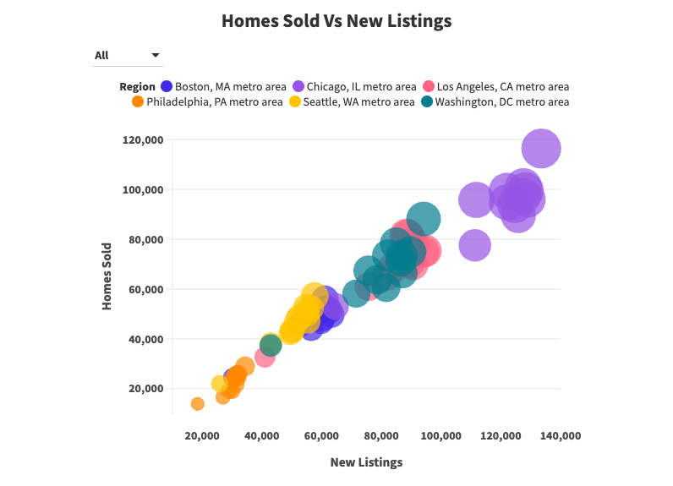

[New Listings Vs Homes Sold | Flourish](https://public.flourish.studio/visualisation/15445017/)

**Visualization Purpose:**

This visualization explores the correlation between the number of homes sold and new homes listed every year for all the specified regions. This graph will provide information about the volatility of the real estate market. If the houses sold are more than new listings then soon the area might go out of the open houses and similarly if the new listings are much more than the number of homes sold, then there would be many unsold estates. This provides very crucial information about the houses market in the regions.

**Data Analysis:**

From the correlation matrix of all the variables in the dataset, we found that the Houses Sold and the number of New listings have a very strong correlation. Due to this, we created a visual representation of both the variables and are able to conclude the linear relationship of both the variables.